Newton, Zachery

Geog576

Final Project

**Title:** City of Omro Park Asset Collector

**Abstract: T**his open-source development will be focused on a mobile first browser based front end and a postgres backend hosted on Amazon Web Services. The front-end deployment will reside on a EC2 instance also hosted on AWS. The application will be focused on the collection of park assets for the City of Omro, WI. The city currently does not have a public facing GIS environment nor does it have any parks mapping available online to the public. The ultimate goal of the application is to collect the existing park boundaries and to collect all assets residing within those park boundaries. The data for the park boundaries will come initially from a description of the parks from the city’s website ([Parks List | Omro WI](https://www.omro-wi.com/parks-recreation/page/parks-list)) and an examination of Winnebago County parcel data to decern City owned parcels. This will be done at the beginning of the project to help set work areas for data collection of the individual assets. The initial data collection would be the first step in the overall objective of creating a park viewer for the city. The application would include a parks boundary layer and the collection would be set up with a point feature layer to denote the various assets within each park. The user would benefit from a browser-based web map that can utilize the mobile device’s location to pinpoint assets. It would also have a search feature, base map gallery, and filtering functionality. Additionally, each feature would have a pop-up to display additional information about the individual assets as well as a photo of the asset.

Data Table:

|  |  |  |
| --- | --- | --- |
| Layer | Description | Source |
| Park Polygon | Derived from Winnebago County Parcels and City of Omro Park List | [Parks List | Omro WI](https://www.omro-wi.com/parks-recreation/page/parks-list)  [Index of /GISOpenData/General](https://wcgisdata.winnebagocountywi.gov/GISOpenData/General/) |
| Park Asset Points | Assets within various parks | Created in the project |
| Terrain Basemap | Esri Basemap of the terrain | https://basemaps.arcgis.com/arcgis/rest/  services/World_Basemap_v2/VectorTileServer |

**System Diagram:**

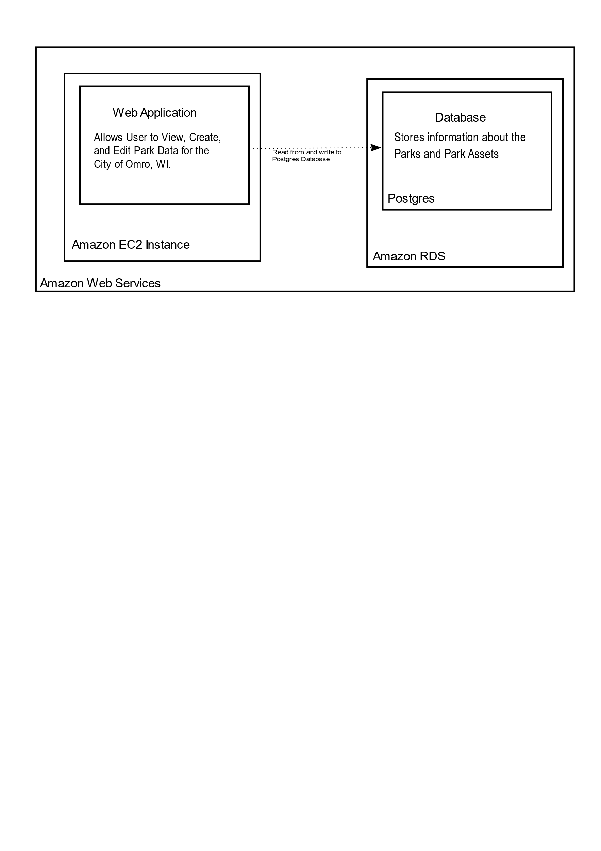

**Wire Frames:**

